horizontal line

Project Summary

|  |  |
| --- | --- |
| Batch details | PGPDSE-FT GURGAON APR24 |
| Team members | Aman Chhabra, Devanshu, Ishika, Shubham Bansal, Umang Agarwal |
| Domain of Project | Retail |
| Proposed project title | **GlowGuide** – Tailored Beauty Product Suggestions |
| Group Number | Group 1 |
| Team Leader | Umang Agarwal |
| Mentor Name | Siddharth Koshta |

Date:

Signature of the Mentor Signature of the Team Leader

Table of Contents

|  |  |  |
| --- | --- | --- |
| Sl NO | Topic | Page No |
| 1 | Overview | 2 |
| 2 | Business problem goals | 2 |
| 3 | Topic survey in depth | 3 |
| 4 | Critical assessment of topic survey | 3 |
| 5 | Methodology to be followed | 3 |
| 6 | References | 4 |

Project Details

**Project Overview**

The Beauty Product Recommendation System is designed to enhance the customer experience by providing personalized beauty product suggestions. Through data collection, cleaning, visualization, clustering, and recommendation techniques, the system makes it easier for users to discover products that align with their preferences. By leveraging data on products’ ingredients, prices, reviews, and ratings, the system offers targeted suggestions, improving the decision-making process and user satisfaction.

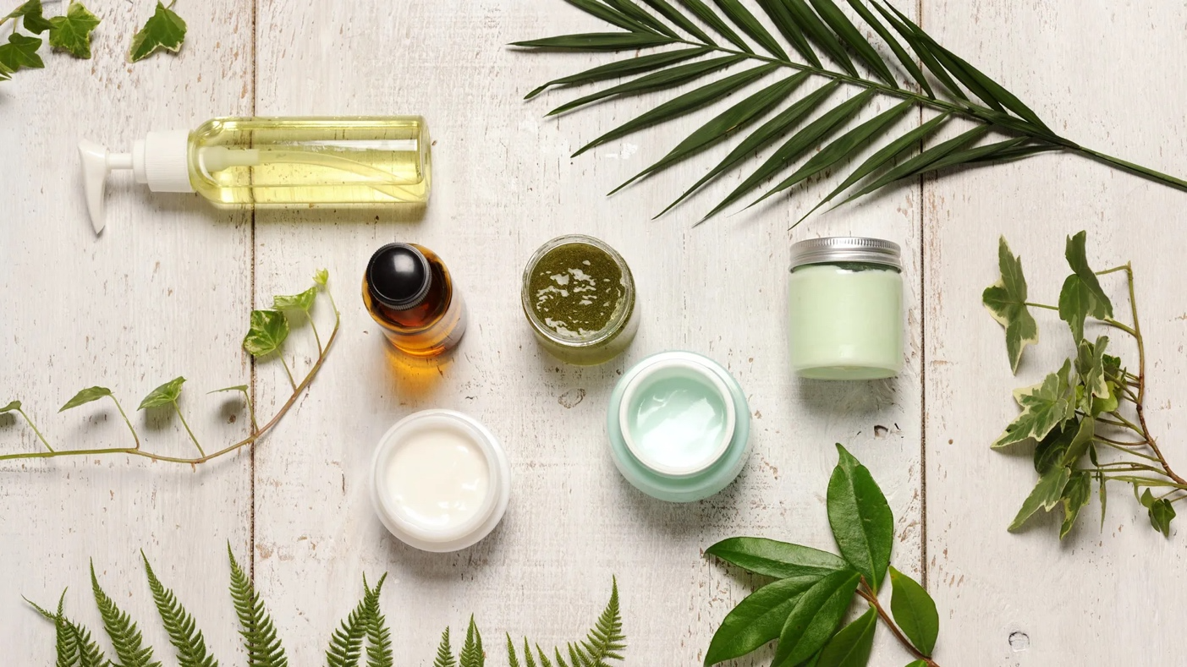

**Business Problem Statement (Goals)**

* Problem Understanding: Customers often face challenges when selecting beauty products due to the overwhelming number of options available. This leads to confusion and suboptimal product choices.
* Business Objective: To develop a system that recommends products based on user preferences, past purchases, and product characteristics, thereby helping customers make informed decisions.
* Approach: Use machine learning algorithms to analyze user behavior, product attributes, and clustering techniques to generate personalized recommendations
* Conclusions: A targeted recommendation system will improve customer satisfaction, increase product discovery, and enhance the overall user experience in online beauty product marketplaces.

**Topic Survey in Brief**

The beauty industry is saturated with an extensive variety of products, which makes it difficult for consumers to choose the right ones. While existing e-commerce platforms provide basic filtering and search capabilities, they often lack advanced personalization features that can accurately match products to individual user needs.

This project aims to tackle this problem by implementing a sophisticated recommendation system using data on beauty products sourced through web scraping. Key data points include product names, prices, ingredients, reviews, and ratings. After data cleaning, we applied clustering algorithms to group similar products. The recommendation engine is then built on these clusters to make suggestions based on user preferences and behavior.

By using advanced machine learning models, this system overcomes the limitations of traditional recommendation engines, offering personalized and relevant product suggestions. As a result, users are more likely to find products that meet their preferences, which enhances their shopping experience and builds trust in the recommendation system.

**Critical Assessment of Topic Survey**

While existing solutions for beauty product recommendations are often generic and limited, they fail to consider key factors like ingredient composition and detailed user preferences. The gap in personalization leads to customer dissatisfaction. This project adds value by integrating diverse data points, such as product ingredients, customer reviews, and detailed ratings, to create a more personalized experience. By addressing these gaps, the system provides better product suggestions tailored to individual needs.

**Methodology to be Followed**

**,,**

1. Data Collection: Scraping data from multiple beauty e-commerce websites, capturing essential details like product names, categories, prices, reviews, and ingredients.
2. Data Cleaning: Preprocessing the collected data to ensure consistency, removing duplicates, handling missing values, and formatting the dataset for analysis.
3. Data Visualization: Visualizing the distribution of products by category, pricing trends, customer ratings, and common ingredient patterns to uncover key insights.

**,**

1. Clustering: Using machine learning clustering techniques (such as K-means or hierarchical clustering) to group similar beauty products based on features like price, ratings, and ingredients.
2. Recommendation System: Building a recommendation engine that uses collaborative filtering and content-based filtering approaches, drawing from clustered data and user preferences.
3. Testing and Evaluation: Assess the recommendation accuracy through metrics like precision, recall, and user satisfaction feedback.

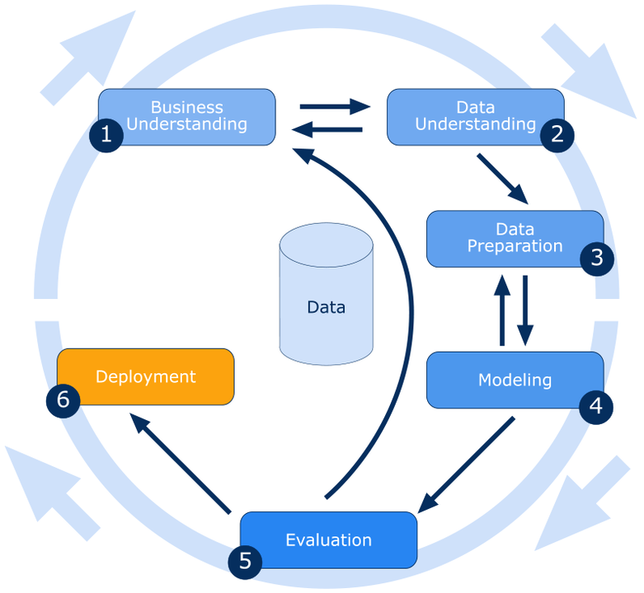

**References**

,,,The references will include various industry reports, academic papers on recommendation systems, and sources used during the web scraping process for beauty product data. These sources may also consist of market analysis reports, blogs, or articles focusing on consumer behavior in the beauty industry.

Hi ,  
  
Hope You are doing Well  
  
I am writing to express my interest in any upcoming opportunities for a Data Scientist role at Appinventive. With a strong background in data science, including experience in SQL, Python, and machine learning models, I believe I can contribute effectively to your team.  
  
Attached is my resume for your review. I would appreciate the chance to discuss how my skills align with your team’s needs.  
  
Thank you for your time and consideration.  
  
Best regards,   
Umang Agarwal   
+91 7055767242   
[agarwalumang830@gmail.com](mailto:agarwalumang830@gmail.com)   
<https://github.com/umangagarwal08>